# Ex No: 3 BUILD A CONVOLUTIONAL NEURAL NETWORK

**AIM:**

To build a simple convolutional neural network with Keras/TensorFlow.

# PROCEDURE:

1. Download and load the dataset.
2. Perform analysis and preprocessing of the dataset.
3. Build a simple neural network model using Keras/TensorFlow.
4. Compile and fit the model.
5. Perform prediction with the test dataset.
6. Calculate performance metrics.

# PROGRAM:

from tensorflow.keras.datasets import fashion_mnist

# Load the Fashion MNIST dataset

(train_images, train_labels), (test_images, test_labels) = fashion_mnist.load_data() from tensorflow.keras.utils import to_categorical

# Reshape the images to add the channel dimension (28x28x1) train_images = train_images.reshape((train_images.shape[0], 28, 28, 1))

test_images = test_images.reshape((test_images.shape[0], 28, 28, 1))

# Normalize the pixel values between 0 and 1 train_images = train_images.astype('float32') / 255.0 test_images = test_images.astype('float32') / 255.0

# One-hot encode the labels

train_labels = to_categorical(train_labels, 10) test_labels = to_categorical(test_labels, 10)

from tensorflow.keras import layers, models

# Build the CNN model model = models.Sequential()

# Add Convolutional layers and MaxPooling

model.add(layers.Conv2D(32, (3, 3), activation='relu', input_shape=(28, 28, 1)))

model.add(layers.MaxPooling2D((2, 2)))

model.add(layers.Conv2D(64, (3, 3), activation='relu'))

model.add(layers.MaxPooling2D((2, 2)))

model.add(layers.Conv2D(64, (3, 3), activation='relu'))

# Add Fully Connected layers model.add(layers.Flatten()) model.add(layers.Dense(64, activation='relu')) model.add(layers.Dense(10, activation='softmax'))

model.summary()

model.compile(optimizer='adam',loss='categorical_crossentropy',metrics=['accuracy']) # Train the model

history = model.fit(train_images, train_labels,epochs=10, batch_size=64, validation_split=0.2) test_loss, test_acc = model.evaluate(test_images, test_labels)

print(f"Test accuracy: {test_acc}")

predictions = model.predict(test_images)

from sklearn.metrics import confusion_matrix, classification_report import matplotlib.pyplot as plt

# Generate confusion matrix

y_pred = predictions.argmax(axis=1) y_true = test_labels.argmax(axis=1)

cm = confusion_matrix(y_true, y_pred) print(classification_report(y_true, y_pred))

# Plotting accuracy and loss curves plt.plot(history.history['accuracy'], label='train accuracy') plt.plot(history.history['val_accuracy'], label='val accuracy') plt.legend()

plt.show()

plt.plot(history.history['loss'], label='train loss') plt.plot(history.history['val_loss'], label='val loss') plt.legend()

plt.show()

# OUTPUT:

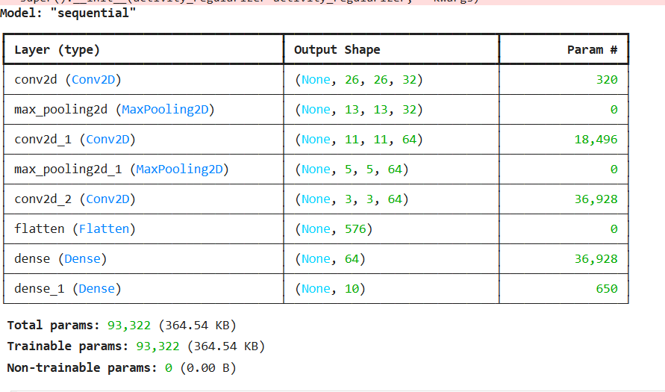

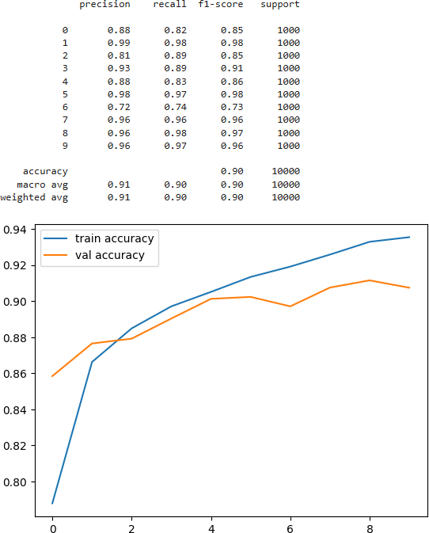

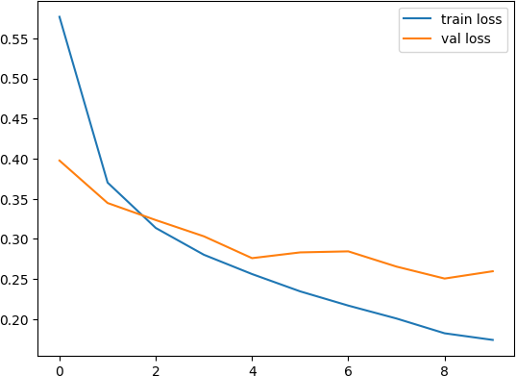

**RESULT:**

Thus a simple convolutional neural network with Keras/TensorFlow is built.